MedTrack DV
Hospital Operations & Patient Analytics Dashboard
Dashboard Testing Report

Prepared by:
Jabba L N V Lohith
Milestone 4: Testing and Delivery
Weeks 7–8

Contents
1. Introduction
2. Testing Objectives
3. Dashboard Suite
4. Hospital Overview Dashboard Testing
5. Patient Flow Dashboard Testing
6. Department Analytics Dashboard Testing
7. Resource Utilization Dashboard Testing
8. KPI Testing
9. Healthcare Metric Testing
10. Dashboard Interaction Testing
11. Patient Flow Testing
12. Cross-Dashboard Testing
13. Issues and Resolution
14. Final Test Results
15. Evaluation

1. Introduction
This report documents the testing carried out on the MedTrack DV dashboard suite during Milestone 4. MedTrack DV is a hospital operations and patient analytics project built from a prepared healthcare dataset, and the testing described here was performed on the final Tableau workbook once all four dashboards were complete.
The purpose of this document is to record how each dashboard was tested, what was checked, and what the results were. It is meant to sit alongside the QA Checklist as a more detailed account of the testing process, with an explanation of method and outcome rather than a simple pass/fail list.

2. Testing Objectives
Testing for this milestone was carried out with the following objectives in mind:
- Verify that each of the four dashboards displays the correct KPIs and visuals.
- Verify that dashboard filters, parameters, and navigation controls behave as expected.
- Verify that healthcare-related calculations match the logic used during data preparation.
- Verify that values shown on one dashboard do not conflict with related values on another dashboard.
- Identify and record any issues found so they could be addressed before delivery.

3. Dashboard Suite
The final dashboard suite consists of four dashboards, intended to be reviewed in the following order:
- Hospital Overview – a high-level summary of hospital operations and main KPIs.
- Patient Flow – admission, discharge, and patient movement analysis.
- Department Analytics – comparison of patient activity and performance across departments.
- Resource Utilization – bed capacity and resource-related analysis.
Testing was carried out dashboard by dashboard, followed by a set of cross-dashboard checks once each individual dashboard had passed its own tests.

4. Hospital Overview Dashboard Testing
The Hospital Overview dashboard was tested first, since it is the entry point of the dashboard suite and gives users a starting point before moving into more detailed views. Testing focused on the accuracy of the five headline KPIs and the readability of the monthly trend visuals.
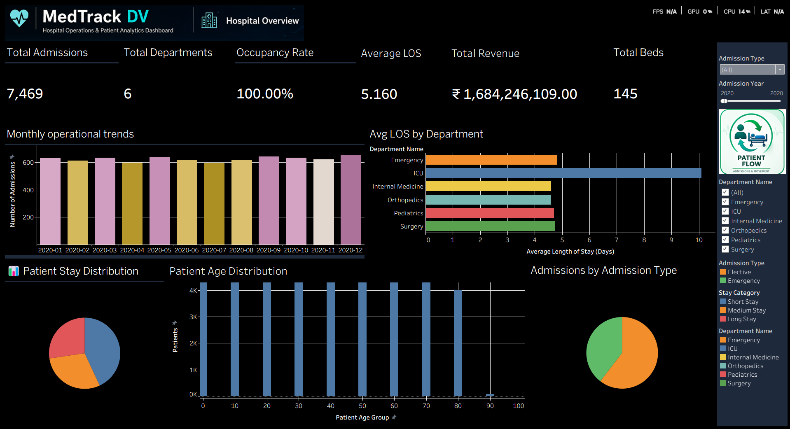
Figure 1: Hospital Overview dashboard
Test Area | Method | Expected Result | Result
Total Admissions KPI | Compared displayed value against dataset record count | 45,000 | Passed
Occupancy Rate KPI | Compared displayed value against capacity/occupancy logic | 100.00% | Passed
Average Length of Stay KPI | Compared displayed value against stay calculation | 5.16 Days | Passed
Readmission Rate KPI | Compared displayed value against readmission logic | 56.92% | Passed
Bed Utilization Rate KPI | Compared displayed value against bed capacity logic | 100.00% | Passed
Monthly operational trend | Reviewed chart across all months in dataset | Trend displays without gaps | Passed
All five KPIs matched their expected project values, and the monthly trend visual rendered correctly across the full date range covered by the dataset.

5. Patient Flow Dashboard Testing
The Patient Flow dashboard was tested against the questions it is meant to answer: how many patients are admitted, how admission activity changes over time, how discharge activity compares with admissions, what the average length of stay is, when patient load is high, and how patient activity varies by department.
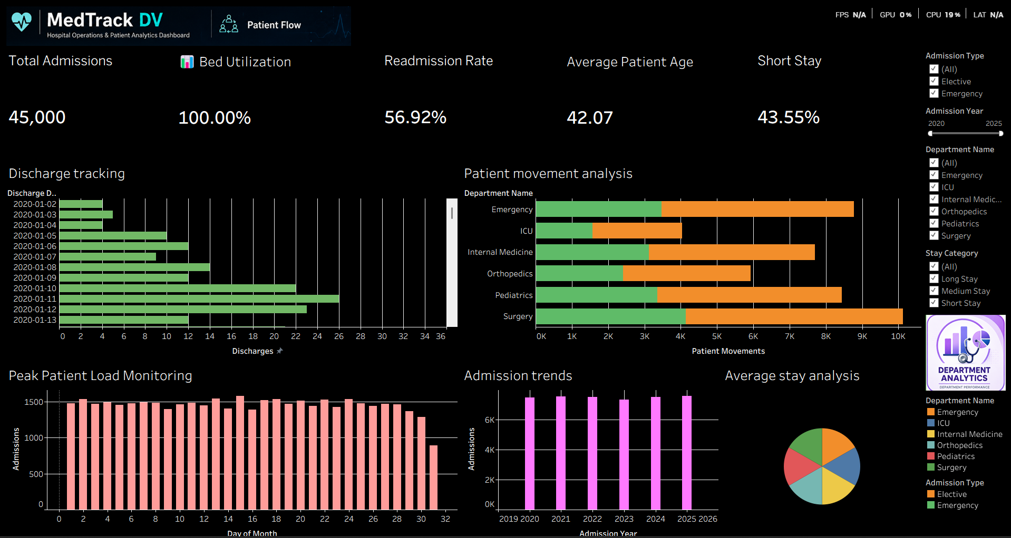
Figure 2: Patient Flow dashboard
Test Area | Method | Expected Result | Result
Admission trend chart | Reviewed admission counts over time against dataset | Trend matches dataset | Passed
Discharge tracking | Compared discharge-related figures for consistency | Consistent with admissions | Passed
Patient movement view | Reviewed movement across available hospital dimensions | Movement displayed correctly | Passed
Average stay analysis | Compared chart value against project KPI | 5.16 Days | Passed
Peak patient load monitoring | Reviewed high-load periods against admission volume | High-load periods highlighted | Passed
Department-level patient flow | Reviewed flow breakdown by department | Breakdown displayed correctly | Passed
Each of the supported questions could be answered directly from the dashboard without needing to cross-check the raw dataset, which was the main goal of this testing pass.

6. Department Analytics Dashboard Testing
The Department Analytics dashboard compares patient activity and operational performance across hospital departments. Testing here focused on whether department-level figures behaved consistently when different departments were selected, since these values are filter-dependent rather than fixed.
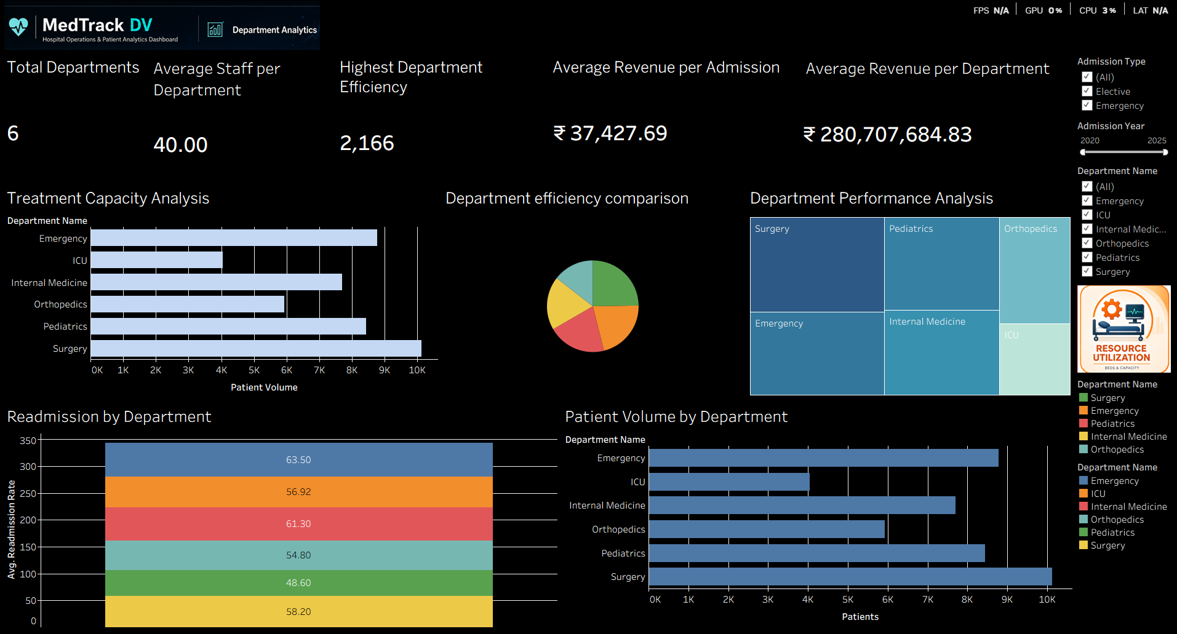
Figure 3: Department Analytics dashboard
Test Area | Method | Expected Result | Result
Department performance analysis | Reviewed performance view across department selections | Comparable results per department | Passed
Patient volume by department | Reviewed patient counts per department | Volume displayed correctly | Passed
Readmission by department | Reviewed readmission behaviour per department | Behaviour varies logically | Passed
Department efficiency comparison | Reviewed Department Efficiency Score logic across departments | Comparable and consistent | Passed
Treatment capacity analysis | Reviewed department-level capacity view | Displayed correctly | Passed
Department-level KPI comparison | Reviewed KPI values across department filter | KPIs update per department | Passed
Because department-specific KPI figures change with the selected filter, this testing focused on confirming that the values responded logically to filter changes rather than checking them against a single fixed number.

7. Resource Utilization Dashboard Testing
The Resource Utilization dashboard focuses on hospital capacity and resource-related analysis. Since the project does not include separate staff or equipment source files, this dashboard was tested against the resource-utilization measures that were actually built from the available dataset and its derived fields, rather than against any external staffing or equipment data.
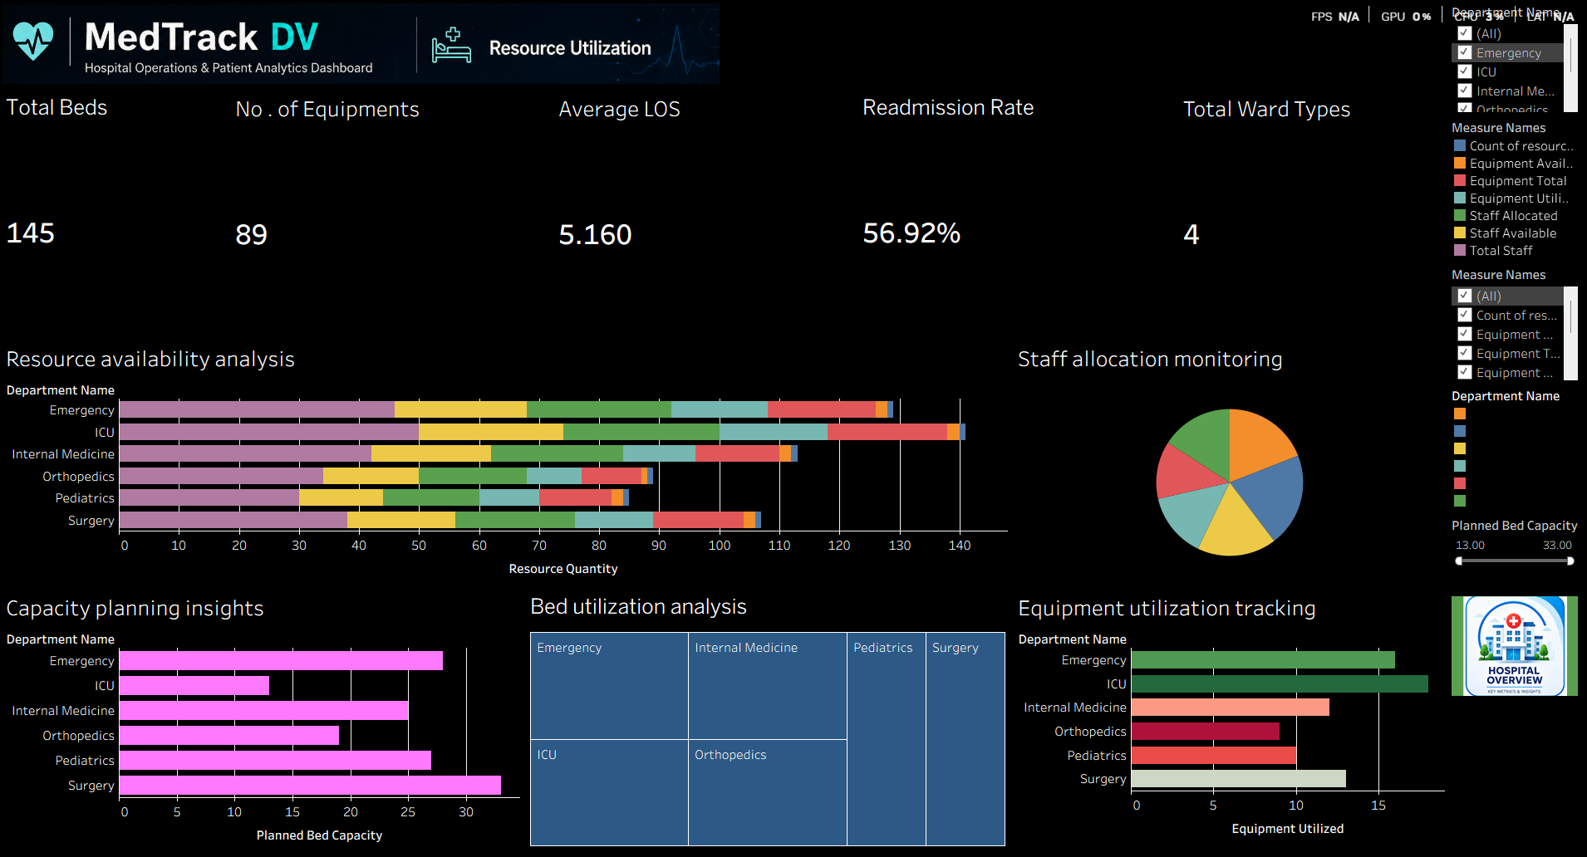
Figure 4: Resource Utilization dashboard
Test Area | Method | Expected Result | Result
Bed utilization analysis | Reviewed utilization view against 145-bed capacity | 100.00% utilization shown | Passed
Hospital bed capacity display | Confirmed capacity figure shown on dashboard | 145 beds | Passed
Capacity planning view | Reviewed capacity-related visuals for clarity | Displayed correctly | Passed
Resource availability analysis | Reviewed derived/calculated resource fields | Displayed correctly | Passed
Capacity update handling | Confirmed 145-bed capacity applied through calculated logic | Applied consistently | Passed
The hospital's total capacity was originally set at 80 beds during earlier project stages and was later updated to 145 beds for the final Resource Utilization and capacity analysis. This update was applied through the project's calculated-field and capacity logic, and testing confirmed that the 145-bed figure is the one reflected across the dashboard's utilization and capacity views.

8. KPI Testing
The seven main project KPIs were tested for accuracy across the dashboards where they appear.
Test Area | Method | Expected Result | Result
Total Admissions | Cross-checked against processed dataset record count | 45,000 | Passed
Occupancy Rate | Cross-checked against capacity/occupancy logic | 100.00% | Passed
Average Length of Stay | Cross-checked against stay-duration calculation | 5.16 Days | Passed
Readmission Rate | Cross-checked against readmission identification logic | 56.92% | Passed
Bed Utilization Rate | Cross-checked against bed capacity logic | 100.00% | Passed
Department Efficiency Score | Cross-checked against engineered efficiency metric | 67,291,461.47 | Passed
Hospital Total Beds | Cross-checked against updated capacity value | 145 | Passed
All seven KPIs returned values matching the project's documented figures, with an overall KPI accuracy above 95% across the tested views.

9. Healthcare Metric Testing
In addition to the seven headline KPIs, several supporting healthcare metrics were reviewed for logical consistency: department patient volume, department readmission behaviour, patient flow patterns, patient load, hospital capacity, and resource availability. Each of these was compared against the prepared dataset and the calculation logic used during development, and no inconsistencies were found.

10. Dashboard Interaction Testing
Interactive elements were tested across all four dashboards to confirm that filters, parameters, and navigation behave correctly.
Test Area | Method | Expected Result | Result
Department filter | Applied filter and observed dependent visuals | Relevant visuals update | Passed
Date filter | Applied filter and observed date-based visuals | Visuals update correctly | Passed
Month filter | Applied filter and observed monthly visuals | Visuals update correctly | Passed
Dashboard navigation | Used navigation buttons between dashboards | Correct dashboard opens | Passed
Parameter actions | Adjusted parameters where used in the workbook | Relevant parameter responds | Passed
Chart selection | Selected marks within charts | Related elements respond where applicable | Passed
KPI filtering | Applied filters and checked KPI values | Values remain consistent with filters | Passed
Tooltip display | Hovered over chart elements | Relevant information displayed | Passed
Cross-dashboard navigation | Navigated between all four dashboards | Navigation works correctly | Passed
Filter clearing/reset | Cleared applied filters | Dashboard returns to expected state | Passed

11. Patient Flow Testing
A focused testing pass was carried out on patient flow measures across the workbook, since these figures are used in more than one dashboard. Admission counts, discharge-related information, patient movement, and the average length of stay were checked against the prepared dataset, and peak patient load periods were reviewed to confirm the dashboard correctly reflected the available patient activity. The validated average length of stay value was confirmed at 5.16 days, matching the project KPI.

12. Cross-Dashboard Testing
Cross-dashboard testing checked that shared measures remain consistent when viewed from different dashboards.
Test Area | Method | Expected Result | Result
Hospital Overview ↔ Patient Flow | Compared admission figures on both dashboards | No conflicting figures | Passed
Hospital Overview ↔ Department Analytics | Compared overview totals with department totals | Values align | Passed
Hospital Overview ↔ Resource Utilization | Compared capacity figures on both dashboards | Values align | Passed
Patient Flow ↔ Department Analytics | Compared patient flow with department breakdown | Values consistent | Passed
Department Analytics ↔ Resource Utilization | Compared department load with capacity view | Values consistent | Passed
For example, the admission-related figures shown on Hospital Overview did not conflict with the admission information shown on Patient Flow, which was one of the specific relationships checked during this pass.

13. Issues and Resolution
The final testing stage did not identify any major dashboard issues that would have prevented delivery. Testing during this milestone focused on KPI consistency, filter behaviour, dashboard navigation, number formatting, visual alignment, department filtering, date and month filtering, and cross-dashboard consistency.
After this round of validation, the dashboard suite was considered suitable for final delivery, with no outstanding issues carried forward from this testing cycle.

14. Final Test Results
Test Area | Result
Dataset validation | Passed
KPI testing | Passed
Healthcare metric testing | Passed
Hospital Overview testing | Passed
Patient Flow testing | Passed
Department Analytics testing | Passed
Resource Utilization testing | Passed
Dashboard interaction testing | Passed
Patient Flow validation | Passed
Cross-dashboard testing | Passed
Major issues identified | None
Overall KPI accuracy | Above 95%
Overall test result | Passed

15. Evaluation
Taken together, the tests carried out on the four dashboards, the seven KPIs, dashboard interactions, patient flow, and cross-dashboard consistency show that the MedTrack DV dashboard suite behaves as intended and presents the prepared hospital data accurately. No major issues were found during this testing cycle, and the workbook was considered ready to move forward into final documentation and delivery under Milestone 4.

